**Pneumonia Detection from Chest X-Ray Images**

**INTRODUCTION**

Pneumonia is a serious respiratory infection that primarily affects the lungs. Timely and accurate diagnosis is crucial for effective treatment and management. Traditionally, pneumonia diagnosis involves clinical examination and chest X-rays, interpreted by radiologists. With advancements in artificial intelligence, especially deep learning, automated systems for pneumonia detection from chest X-ray images can assist in early diagnosis and potentially improve patient outcomes.

**GOAL OF THE PROJECT**

The goal of this project is to develop a deep learning model capable of detecting pneumonia from chest X-ray images. This involves building and training a Convolutional Neural Network (CNN) to classify X-ray images as either normal or showing signs of pneumonia.

**LITERATURE SURVEY**

Over the past decade, deep learning has been extensively used by researchers to detect lung infections and diseases from chest X-rays. For instance, CheXNet, a 121-layer CNN developed by Rajpurkar et al., was trained on 100,000 chest X-ray images from 14 different diseases. This approach outperformed radiologists in pneumonia detection when tested on 420 chest X-rays. Another study developed a CNN from scratch to retrieve features from chest X-ray images, achieving high classification performance. Wu et al. proposed an adaptive average filtration CNN combined with random forest for pneumonia prediction, which improved accuracy by reducing image noise. However, CNN models require large labeled datasets and substantial computational resources.

Transfer learning (TL) has become popular for its efficiency, reduced costs, and fewer data requirements. Ayan and Ünver fine-tuned TL with Xception and VGG16 architectures, achieving high diagnostic accuracy with minimal computational overhead. Other studies combined the outputs of models like InceptionV3, ResNet18, and GoogLeNet to improve reliability. Rahman et al. applied TL with pretrained CNNs from ImageNet, using various classification strategies for pneumonia detection. Togacar et al. used multiple CNN models for feature extraction, enhancing classification accuracy with feature selection techniques.

Innovations like CapsNet and Octave-Like Convolutional Neural Networks have been explored to reduce computational costs while maintaining accuracy. Liang and Zheng used a CNN with residual junctions and dilated convolutions for pneumonia detection, highlighting the impact of TL. Kermany and Rajaraman et al. developed CNN-based approaches using TL and region of interest (ROI) techniques, although challenges in achieving high efficiency remain.

In conclusion, recent research has advanced CNN-based methods for pneumonia detection, with a trend towards leveraging TL and ensemble learning to enhance accuracy and efficiency. Our proposed method combines three CNN models, including a vision transformer, showing promising improvements over existing techniques with fewer layers and features.

**FINDINGS FROM LITERATURE SURVEY**

**1. Effectiveness of Deep Learning Models**: Deep learning models, particularly CNNs, have proven highly effective in detecting pneumonia from chest X-ray images, outperforming traditional methods.

**2. Advantages of Transfer Learning:** Transfer learning significantly enhances model performance while reducing the need for extensive labeled datasets and computational resources.

**3. Innovative Approaches and Challenges**: Lightweight CNN variants and ensemble methods address challenges such as computational complexity and the need for robust feature extraction, driving advancements in pneumonia detection.

**4. Diagnostic Reliability:** Combining multiple models and employing advanced architectures like vision transformers can improve diagnostic accuracy and efficiency.

**SCOPE**

The project focuses on using Deep learning for image classification. The dataset includes chest X-ray images labelled as pneumonia or normal. The scope includes data pre-processing, model development, training, evaluation, and visualization of results.

**OBJECTIVE**

The objectives according to SMART are:

1. **Specific:** The objective specifies developing a pneumonia detection system using CNN with a dataset of 5863 pneumonia-affected patients.
2. **Measurable:** Success can be measured by the accuracy of pneumonia detection achieved by the CNN model.
3. **Attainable:** Given the availability of datasets and the use of established Deep Learning techniques like CNN, the objective appears attainable.
4. **Relevant:** The project addresses a relevant issue in healthcare—early detection of pneumonia using AI, which can potentially benefit healthcare providers and patients.
5. **Time-bound:** The project aims to develop and deploy a pneumonia detection system within, leveraging CNN for rapid and accurate predictions.

**DATA COLLECTION**

1. **Data source and description:**

The dataset is sourced from the Kaggle – Chest X-Ray Images (Pneumonia). The dataset consists of chest X-ray images categorized into training, validation, and test sets. Each image is labelled as 'Pneumonia' or 'Normal'.

1. **Data Preprocessing**:
   * Rescaling pixel values to the range [0, 1].
   * Data augmentation techniques such as shearing, zooming, and horizontal flipping to enhance model generalization.
   * Splitting data into training, validation, and test sets.
2. **Data Splitting**:

The data is divided into training (70%), validation (20%), and test (10%) sets.

**MODEL SELECTION AND DEVELOPMENT**

1. **Model Selection**:

A custom CNN model is selected due to its suitability for image classification tasks.

1. **Why CNN?**

Convolutional Neural Networks (CNNs) are preferred for pneumonia detection from chest X-ray images due to several key advantages:

1. **Automated Feature Extraction**: CNNs autonomously learn hierarchical features directly from pixel data, eliminating the need for manual feature engineering used in traditional algorithms.
2. **Robust to Image Variability**: They handle variations in image orientation, position, and scale through shared-weight filters and pooling layers, ensuring robustness across diverse chest X-ray images.
3. **Superior Accuracy**: CNNs consistently achieve state-of-the-art results in image classification tasks, including medical imaging, by learning complex decision boundaries that traditional algorithms struggle with.
4. **Efficiency and Scalability**: They are computationally efficient, leveraging parameter sharing and parallel processing capabilities, making them suitable for large-scale medical datasets.
5. **Adaptability and Interpretability**: Once trained, CNN models generalize well to new data and can provide insights into learned features through visualization techniques, enhancing interpretability.

In summary, CNNs excel in pneumonia detection from chest X-ray images by automatically learning discriminative features, handling image variability effectively, achieving high accuracy, and maintaining efficiency across large datasets. These attributes make CNNs superior to traditional algorithms for developing robust and accurate diagnostic tools in medical imaging.

1. **Model Architecture**:

Here we use Sequential model and the architecture includes:

* + Convolutional layers with Rectified Linear Unit (ReLU) activation.
  + MaxPooling layers for down-sampling.
  + Fully connected (Dense) layers.
  + Dropout layers to prevent overfitting.
  + Sigmoid activation for binary classification.

1. **Implementation Details**:

The model is implemented using TensorFlow and Keras libraries.

1. **Tensorflow and Keras**

* **TensorFlow** - is an open-source deep learning framework developed by Google Brain. It is designed for scalability and deployment across a range of devices and platform.
* **Keras** - Originally developed as a standalone deep learning library, Keras is now integrated tightly with TensorFlow as its high-level API. It focuses on simplicity, ease of use, and rapid prototyping.

1. **Why Tensorflow and Keras?**

TensorFlow and Keras are widely chosen for developing deep learning models, especially for tasks like pneumonia detection from chest X-ray images. Here’s why:

* 1. **Ease of Use and High-Level API:** 
     1. Keras provides a user-friendly interface to build, train, and deploy models within TensorFlow. It simplifies model prototyping without needing to handle low-level computations.
     2. Tensorflow offers extensive functionalities for designing and implementing neural networks, allowing customization for research and production needs.
  2. **Documentation and Community Support:**

Both TensorFlow and Keras have extensive documentation and a supportive community. This ensures rapid updates, troubleshooting, and access to best practices for tasks like medical image analysis.

**c. Performance and Scalability:**

TensorFlow optimizes hardware resources with its computational graph abstraction, crucial for scaling models on large datasets. This scalability is vital for tasks requiring substantial computational resources.

In summary, TensorFlow and Keras are chosen for their user-friendly interfaces, strong community support, scalability, integration capabilities, and advancement in deep learning technologies. These attributes collectively make them ideal for developing and deploying effective pneumonia detection models from chest X-ray images.

**TRAINING AND EVALUATION**

1. **Training Process**:

The model is trained using the training dataset. Early stopping and learning rate reduction callbacks are used to prevent overfitting and optimize learning.

1. **Evaluation Metrics**:

Metrics include accuracy, precision, recall, and F1-score.

#### ****FINE-TUNING AND OPTIMIZATION****

#### ****Hyperparameter Tuning****:

#### Hyperparameters such as learning rate, batch size, and the number of epochs are tuned to optimize model performance.

1. **Model Improvements**:

Iterative improvements include adjusting the number of layers, filters, and incorporating dropout layers to reduce overfitting.

#### RESULT AND ANALYSIS

1. **Visualizations**:

Visualizations include training/validation accuracy and loss graphs, confusion matrices, and classification reports.

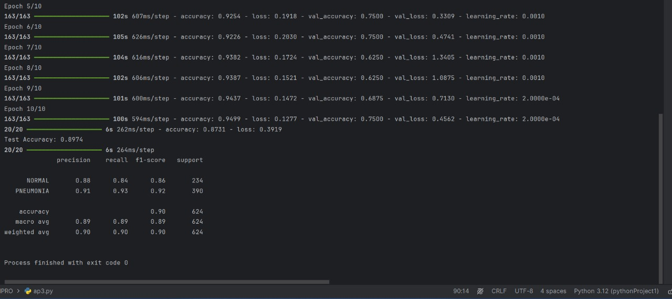

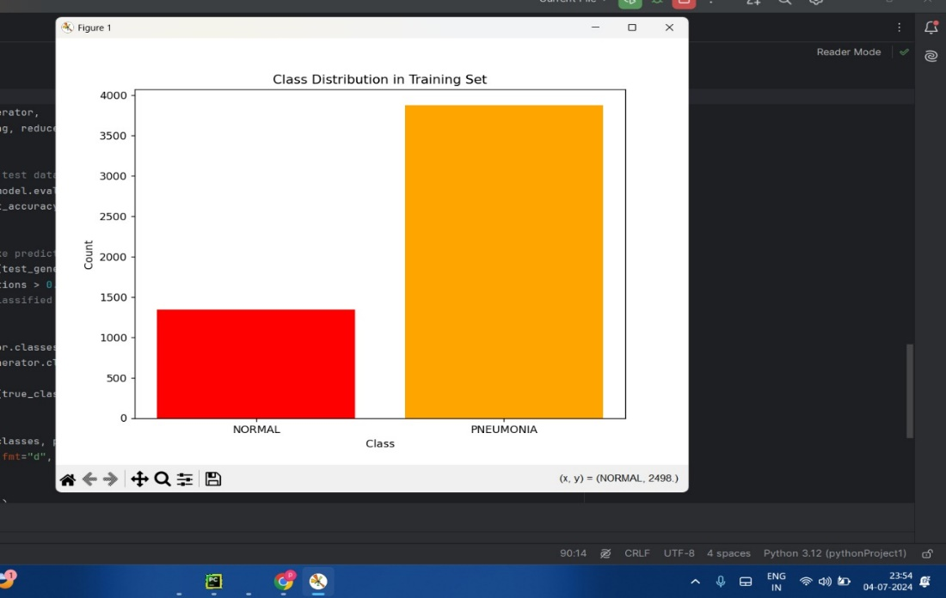

1. **Interpretation of Results**:

The model's performance is analysed based on the confusion matrix

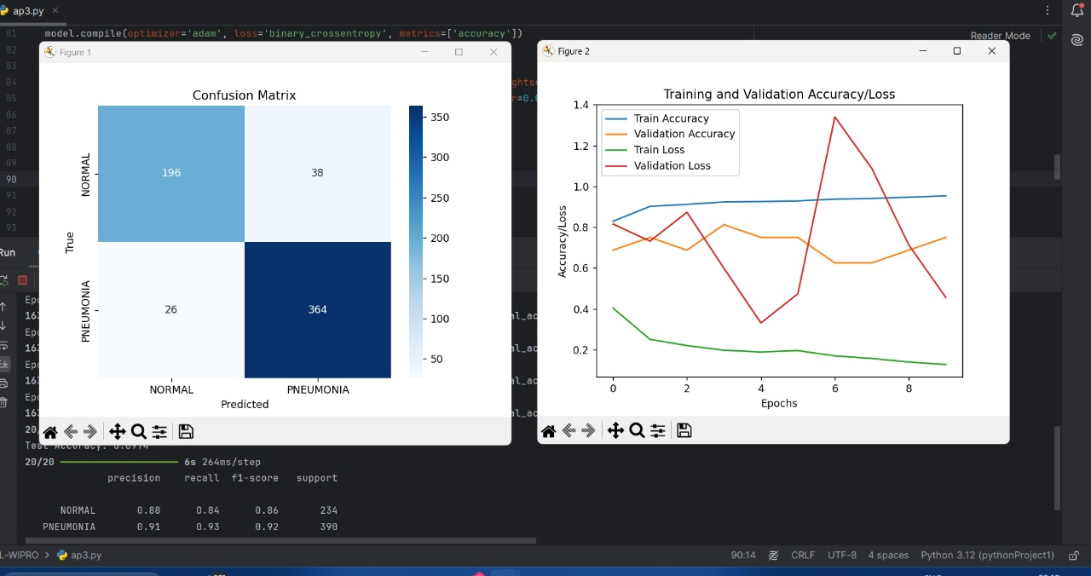

**TIMELINE AND MILESTONE**

|  |  |  |
| --- | --- | --- |
| **Date** | **Thanushree** | **Vishnujeeth** |
| 3/07/2024 | * Understood the project objectives. * Downloaded and reviewed the dataset. * Started preparing documentation. * Gathered information for documentation, including scope, introduction, and literature survey. | * Understood the project objectives. * Downloaded and reviewed the dataset. * Started preparing documentation. * Edited the gathered information for documentation. |
| 4/07/2024 | * Worked on the coding part. * Completed training and evaluation. * Worked on visualization. * Completed the documentation. | * Worked on the coding part. * Selected and developed the CNN model. * Worked on visualization. * Ensured the code was functional and well-optimized. |